Join us for Our 2020 Monthly  PPG WorkshopS  When:  Saturday Dates & Topics on the Back  TIME:  12pm-3pm  Doors open at 11:45am  Where:  Exchange Club CAP Center  2300 10th Court South, Birmingham, Al 35205  www.4CAP.org | Cost  $25  REGISTER & PAY ONLINE AT  WWW.4CAP.ORG  Or stop by the office during business hours to pay your $ 25 to register.  All Fees are non-refundable.  Reserved Seating Required  No payments will be accepted the day of the workshops.  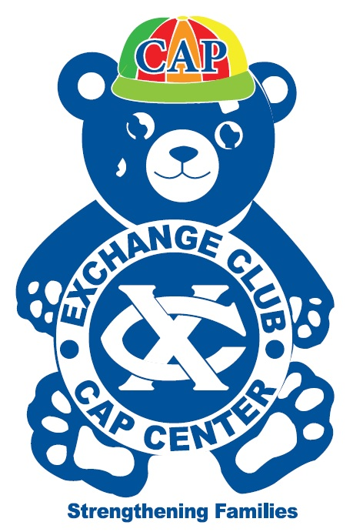  PPG Workshops are opportunities for parents & caregivers to complete 3 of their required Positive Parenting Group (PPG) classes in one day. The topics covered will not be duplicates.  Classes are open to the public & to parents with kids 0-17 years old.  Seating limited to 20 participants.  No partial credit will be given; you must stay for the entire workshop.

Month | Topic
Saturday, Jan 18, 2020 | PPG Workshop: Energy Matters
Saturday, Feb 15, 2020 | PPG Workshop: Separation, Visitation & Reunification
Saturday, March 21, 2020 | PPG Workshop: Safe Kids for Parents
April | No Workshop
Saturday, May 9, 2020 | PPG Workshop: Bullying
Saturday, June 20, 2020 | PPG Workshop: Grandparents as Parents
Saturday, July 18, 2020 | PPG Workshop: Co-Parenting & Healthy Relationships
Saturday, August 15, 2020 | PPG Workshop: Back to School
Saturday, September 5, 2020 | PPG Workshop: The Power of Play
Saturday, October 17, 2020 | PPG Workshop: Family Traditions
November | No Workshop
December | No Workshop
2020 PPG Workshop Schedule

